Story 2 - The Feds Dual Mandate

waheeb Algabri

Table of Contents

library(tidyverse)  
library(openintro)  
library(tidyverse)  
library(fredr)  
library(httr)  
library(devtools)  
library(jsonlite)  
library(lubridate)  
library(zoo)

# Read in API keys

# API Key for BLS   
bls_key <- "63914d4df0f240fc8da9b5cfd9dd8158"  
  
# API Key for FRED  
fred_key <- "51ad4dae4f5ed3c82b1184efb95ca4df"

# BLS API Data Retrieval

year_ranges <- list(c('2005', '2024'), c('1985', '2005'))  
  
cpi <- data.frame()  
ue <- data.frame()  
  
for (year_range in year_ranges) {  
 request <- list(  
 'seriesid' = c('CUUR0000SA0L1E', 'LNS14000000'),   
 'startyear' = year_range[1],   
 'endyear' = year_range[2],  
 'registrationkey' = bls_key  
 )  
  
 # Use httr for BLS API requests  
 response <- POST("https://api.bls.gov/publicAPI/v2/timeseries/data/",  
 body = request, encode = "json")  
 json <- fromJSON(content(response, as = "text"))  
   
 df1 <- json$Results$series$data[[1]]  
 cpi <- rbind(cpi, df1[c('year', 'period', 'value')])  
   
 df2 <- json$Results$series$data[[2]]  
 ue <- rbind(ue, df2[c('year', 'period', 'value')])  
}  
  
# Process the CPI data  
cpi <- cpi %>%  
 mutate(  
 month = as.numeric(str_remove(period, 'M')),  
 year = as.numeric(year),  
 value = as.numeric(value)  
 )  
  
# Process the Unemployment data  
ue <- ue %>%  
 mutate(  
 month = as.numeric(str_remove(period, 'M')),  
 year = as.numeric(year),  
 value = as.numeric(value)  
 )

# FRED API Data Retrieval

# Set FRED API key  
fredr_set_key(fred_key)  
  
  
# Retrieve data from FRED API  
fed_funds <- fredr(  
 series_id = 'FEDFUNDS',  
 observation_start = as.Date('1985-01-01'),  
 observation_end = as.Date('2024-02-01')  
)  
  
# Processing fed funds rate  
fed_funds <- fed_funds %>%  
 mutate(  
 year = year(date),  
 month = month(date)  
 )  
  
fed_target <- fredr(  
 series_id = 'DFEDTARU',  
 observation_start = as.Date('1985-01-01'),  
 observation_end = as.Date('2024-02-01')  
)  
  
fed_target <- fed_target %>%  
 mutate(  
 year = year(date),  
 month = month(date)  
 )  
  
recession <- fredr(  
 series_id = 'JHDUSRGDPBR',  
 observation_start = as.Date('1985-01-01'),  
 observation_end = as.Date('2024-02-01')  
)  
  
recession <- recession %>%  
 mutate(  
 year = year(date),  
 month = month(date)  
 )  
  
# Recession dates  
recession_dates <- recession %>%  
 mutate(recession_start = value == 1 & lag(value) == 0,  
 recession_end = value == 1 & lead(value) == 0) %>%  
 replace_na(list(recession_start = TRUE)) %>%  
 filter(recession_start | recession_end) %>%  
 mutate(period_id = cumsum(recession_start)) %>%  
 group_by(period_id) %>%  
 summarise(start = min(date), end = max(date)) %>%  
 ungroup()

# Merging and Creating New Columns

df <- left_join(cpi, ue, by = c('year', 'month')) %>%  
 left_join(fed_funds, by = c('year', 'month')) %>%  
 left_join(fed_target, by = 'date') %>%  
 rename(  
 cpi = value.x, ue = value.y,   
 fed_funds = value.x.x, fed_target = value.y.y  
 ) %>%  
 select(date, cpi, ue, fed_funds, fed_target) %>%  
 arrange(date) %>%  
 mutate(  
 fed_target = if_else(is.na(fed_target), ceiling(fed_funds * 4) / 4, fed_target),  
 cpi_growth = (cpi/lag(cpi, n = 12) - 1) * 100  
 )   
  
head(df)

## date cpi ue fed_funds fed_target cpi_growth  
## 1 1985-01-01 106.9 7.3 8.35 8.50 NA  
## 2 1985-02-01 107.4 7.2 8.50 8.50 NA  
## 3 1985-03-01 107.9 7.2 8.58 8.75 NA  
## 4 1985-04-01 108.2 7.3 8.27 8.50 NA  
## 5 1985-05-01 108.6 7.2 7.97 8.00 NA  
## 6 1985-06-01 108.8 7.4 7.53 7.75 NA

# clean data

df<- na.omit(df)  
head(df, 15)

## date cpi ue fed_funds fed_target cpi_growth  
## 13 1986-01-01 111.6 6.7 8.14 8.25 4.396632  
## 14 1986-02-01 111.9 7.2 7.86 8.00 4.189944  
## 15 1986-03-01 112.3 7.2 7.48 7.50 4.077850  
## 16 1986-04-01 112.7 7.1 6.99 7.00 4.158965  
## 17 1986-05-01 112.9 7.2 6.85 7.00 3.959484  
## 18 1986-06-01 113.1 7.2 6.92 7.00 3.952206  
## 19 1986-07-01 113.5 7.0 6.56 6.75 4.128440  
## 20 1986-08-01 113.8 6.9 6.17 6.25 4.021938  
## 21 1986-09-01 114.5 7.0 5.89 6.00 4.090909  
## 22 1986-10-01 115.1 7.0 5.85 6.00 3.974706  
## 23 1986-11-01 115.4 6.9 6.04 6.25 3.776978  
## 24 1986-12-01 115.5 6.6 6.91 7.00 3.773585  
## 25 1987-01-01 115.8 6.6 6.43 6.50 3.763441  
## 26 1987-02-01 116.1 6.6 6.10 6.25 3.753351  
## 27 1987-03-01 116.8 6.6 6.13 6.25 4.007124

# Check for missing values  
sum(is.na(df))

## [1] 0

# Visualizations: Levels

df %>%  
 pivot_longer(cols = c(cpi_growth, ue, fed_funds)) %>%  
 ggplot(aes(x = date, y = value, color = name)) +  
 geom_line(size = 0.8) +   
 geom_rect(  
 data = recession_dates,   
 aes(xmin = start, xmax = end, ymin = 0, ymax = 15),  
 fill = 'blue', alpha = 0.3, inherit.aes = FALSE  
 ) +   
 ggtitle('Fed Funds Rate, Unemployment and Inflation Over Time') +  
 xlab('Date') +  
 ylab('Percent (%)') +   
 scale_color_manual(  
 values = c('cpi_growth' = 'chartreuse4', 'fed_funds' = 'dodgerblue2', 'ue' = 'coral3'),   
 name = '',   
 labels = c('cpi_growth' = 'Inflation', 'fed_funds' = 'Fed Funds Rate', 'ue' = 'Unemployment')  
 ) +  
 theme(  
 plot.title = element_text(hjust = 0.5),  
 legend.position = 'bottom',  
 panel.background = element_blank()  
 )

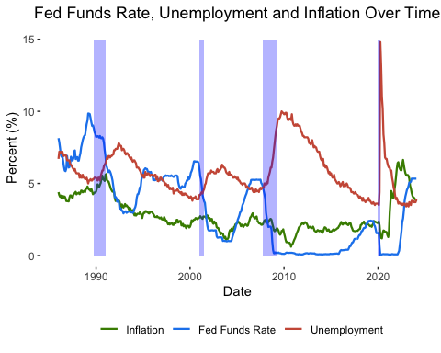 # Identify Rate & Hike Cycles

df <- df %>%  
 mutate(  
 fed_roll_peak = rollapply(  
 fed_target, width = 52, FUN = max,   
 align = 'center', fill = c(NA, NA, 'extend')  
 ),  
 fed_roll_valley = rollapply(  
 fed_target, width = 52, FUN = min,   
 align = 'center', fill = c(NA, NA, 'extend')  
 ),  
 fed_status = case_when(  
 fed_target == fed_roll_peak & fed_target > lead(fed_target) ~ 'peak',  
 fed_target == fed_roll_valley & fed_target < lead(fed_target) ~ 'valley',  
 .default = 'between'  
 )  
 ) %>%  
 select(-fed_roll_peak, -fed_roll_valley)  
  
# The rest of the loop logic remains unchanged

# Fine-Tune Dates and Set Up Cycle DFs

cut_cycles <- data.frame(  
 start = as.Date(c('1989-05-01','1995-05-01','2000-07-01','2007-03-01','2019-07-01')),  
 end = as.Date(c('1992-12-01','1999-01-01','2004-01-01','2010-01-01','2020-04-01'))  
)  
  
hike_cycles <- data.frame(  
 start = as.Date(c('1992-12-01','1999-01-01','2004-01-01','2016-01-01','2022-02-01')),  
 end = as.Date(c('1995-05-01','2000-07-01','2007-03-01','2019-07-01','2024-01-01'))  
)  
  
ggplot() +   
 geom_line(data = df, aes(x = date, y = ue, color = 'Unemployment')) +  
 geom_line(data = df, aes(x = date, y = cpi_growth, color = 'Inflation')) +  
 geom_rect(  
 data = cut_cycles, aes(xmin = start, xmax = end, ymin = -Inf, ymax = Inf, fill = 'Rate Cut Cycle'),  
 alpha = 0.3, inherit.aes = FALSE  
 ) +  
 geom_rect(  
 data = hike_cycles, aes(xmin = start, xmax = end, ymin = -Inf, ymax = Inf, fill = 'Rate Hike Cycle'),  
 alpha = 0.3, inherit.aes = FALSE  
 ) +  
 ggtitle('Rate Cut Versus Hike Cycles with Inflation and Unemployment') +  
 xlab('Date') +  
 ylab('Percent (%)') +   
 scale_fill_manual(  
 values = c('Rate Cut Cycle' = 'coral3', 'Rate Hike Cycle' = 'dodgerblue2'),   
 name = '',   
 labels = c('Rate Cut Cycle', 'Rate Hike Cycle')  
 ) +  
 scale_color_manual(  
 values = c('Unemployment' = 'chartreuse4', 'Inflation' = 'firebrick2'),  
 name = '',  
 labels = c('Unemployment', 'Inflation')  
 ) +  
 theme(  
 plot.title = element_text(hjust = 0.5),  
 legend.position = 'bottom',  
 panel.background = element_blank()  
 )

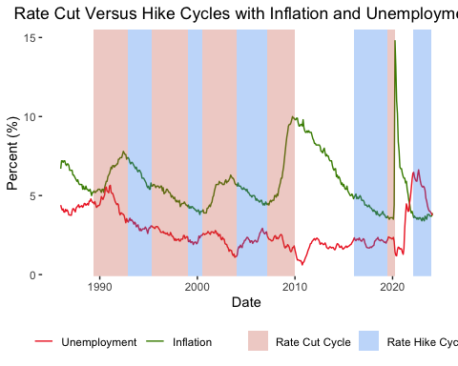

# Calculate changes in UE and CPI after each cycle

for (row in 1:nrow(cut_cycles)) {  
   
 time_to_change <- as.period(hike_cycles[row, 2] - cut_cycles[row, 2])  
 obs_period <- if_else(time_to_change < months(60), time_to_change, months(60))  
   
 cut_cycles[row, 'obs_period_end'] <- cut_cycles[row, 2] + obs_period  
   
 cut_cycles[row, 'ff_change'] <-   
 df[df$date == cut_cycles[row, 2], 'fed_funds'] -   
 df[df$date == cut_cycles[row, 1], 'fed_funds']  
   
 cut_cycles[row, 'infl_change'] <-   
 df[df$date == cut_cycles[row, 2] + obs_period, 'cpi_growth'] -  
 df[df$date == cut_cycles[row, 2], 'cpi_growth']  
   
 cut_cycles[row, 'ue_change'] <-   
 df[df$date == cut_cycles[row, 2] + obs_period, 'ue'] -   
 df[df$date == cut_cycles[row, 2], 'ue']  
}  
  
for (row in 1:nrow(hike_cycles)) {  
   
 if (row == nrow(hike_cycles)) {  
 obs_period <- 0  
 adjustment <- 1  
 } else {  
 time_to_change <- as.period(cut_cycles[row+1, 2] - hike_cycles[row, 2])  
 obs_period <- if_else(time_to_change < months(60), time_to_change, months(60))  
 adjustment <- 0  
 }  
   
 hike_cycles[row, 'obs_period_end'] <- hike_cycles[row, 2] + obs_period  
   
 hike_cycles[row, 'ff_change'] <-   
 df[df$date == hike_cycles[row, 2], 'fed_funds'] -   
 df[df$date == hike_cycles[row, 1], 'fed_funds']  
   
 hike_cycles[row, 'infl_change'] <-   
 df[df$date == hike_cycles[row, 2] + obs_period, 'cpi_growth'] -   
 df[df$date == hike_cycles[row, 2 - adjustment], 'cpi_growth']  
   
 hike_cycles[row, 'ue_change'] <-   
 df[df$date == hike_cycles[row, 2] + obs_period, 'ue'] -  
 df[df$date == hike_cycles[row, 2 - adjustment], 'ue']  
}  
  
cut_cycles <- cut_cycles %>%  
 mutate(label = str_c(  
 'Cut Cycle: ', format(start, "%b-%y"),  
 ' – ', format(end, "%b-%y"),  
 ' / Observation Period: ', format(end, "%b-%y"),   
 ' – ', format(obs_period_end, "%b-%y")  
 ))  
  
hike_cycles <- hike_cycles %>%  
 mutate(label = str_c(  
 'Hike Cycle: ', format(start, "%b-%y"),  
 ' – ', format(end, "%b-%y"),  
 ' / Observation Period: ', format(end, "%b-%y"),   
 ' – ', format(obs_period_end, "%b-%y")  
 ))  
  
hike_cycles[5,7] <- 'Hike Cycle: Feb-22 – Jan-24 / Observation Period: Feb-22 – Jan-24'  
  
cut_cycles

## start end obs_period_end ff_change infl_change ue_change  
## 1 1989-05-01 1992-12-01 1995-05-01 -6.89 -0.24717665 -1.8  
## 2 1995-05-01 1999-01-01 2000-07-01 -1.38 0.09242114 -0.3  
## 3 2000-07-01 2004-01-01 2007-03-01 -5.54 1.30441157 -1.3  
## 4 2007-03-01 2010-01-01 2015-01-01 -5.15 0.09528951 -4.1  
## 5 2019-07-01 2020-04-01 2024-01-01 -2.35 2.42958952 -11.1  
## label  
## 1 Cut Cycle: May-89 – Dec-92 / Observation Period: Dec-92 – May-95  
## 2 Cut Cycle: May-95 – Jan-99 / Observation Period: Jan-99 – Jul-00  
## 3 Cut Cycle: Jul-00 – Jan-04 / Observation Period: Jan-04 – Mar-07  
## 4 Cut Cycle: Mar-07 – Jan-10 / Observation Period: Jan-10 – Jan-15  
## 5 Cut Cycle: Jul-19 – Apr-20 / Observation Period: Apr-20 – Jan-24

hike_cycles

## start end obs_period_end ff_change infl_change ue_change  
## 1 1992-12-01 1995-05-01 1999-01-01 3.09 -0.6820633 -1.3  
## 2 1999-01-01 2000-07-01 2004-01-01 1.91 -1.3402528 1.7  
## 3 2004-01-01 2007-03-01 2010-01-01 4.26 -0.8978150 5.4  
## 4 2016-01-01 2019-07-01 2020-04-01 2.06 -0.7778993 11.1  
## 5 2022-02-01 2024-01-01 2024-01-01 5.25 -2.5524621 -0.1  
## label  
## 1 Hike Cycle: Dec-92 – May-95 / Observation Period: May-95 – Jan-99  
## 2 Hike Cycle: Jan-99 – Jul-00 / Observation Period: Jul-00 – Jan-04  
## 3 Hike Cycle: Jan-04 – Mar-07 / Observation Period: Mar-07 – Jan-10  
## 4 Hike Cycle: Jan-16 – Jul-19 / Observation Period: Jul-19 – Apr-20  
## 5 Hike Cycle: Feb-22 – Jan-24 / Observation Period: Feb-22 – Jan-24

Plot separate Bar Charts

cut_plot <- cut_cycles %>%  
 pivot_longer(cols = c(ff_change, ue_change)) %>%   
 mutate(  
 end = as.character(year(end)),  
 value = (value)  
 ) %>%  
 ggplot(aes(end, value, fill = name)) +  
 geom_col(position = position_dodge()) +  
 ggtitle('Fed Funds Rate Hikes and Resulting Changes in Unemployment') +  
 xlab(NULL) +  
 ylab('Change (%)') +   
 scale_fill_manual(  
 values = c('ff_change' = 'dodgerblue2', 'ue_change' = 'firebrick2'),   
 name = NULL,   
 labels = c('ff_change' = 'Change in Fed Funds Rate', 'ue_change' = 'Change in Unemployment')  
 ) +  
 theme(  
 plot.title = element_text(hjust = 0.5),  
 panel.background = element_blank(),  
 legend.position = 'bottom', legend.box = 'vertical',  
 axis.ticks.x = element_blank()  
 )  
  
hike_plot <- hike_cycles %>%  
 mutate(  
 end = as.character(year(end)),  
 infl_change = (infl_change)  
 ) %>%  
 pivot_longer(cols = c(ff_change, infl_change)) %>%   
 ggplot(aes(end, value, fill = name)) +  
 geom_col(position = position_dodge()) +  
 ggtitle('Fed Funds Rate Hikes and Resulting Changes in Inflation') +  
 xlab(NULL) +  
 ylab('Change (%)') +   
 scale_fill_manual(  
 values = c('ff_change' = 'dodgerblue2', 'infl_change' = 'chartreuse4'),   
 name = NULL,   
 labels = c('ff_change' = 'Change in Fed Funds Rate', 'infl_change' = 'Change in Inflation')  
 ) +  
 theme(  
 plot.title = element_text(hjust = 0.5),  
 panel.background = element_blank(),  
 legend.position = 'bottom', legend.box = 'vertical',  
 axis.ticks.x = element_blank()  
 )  
  
cut_plot

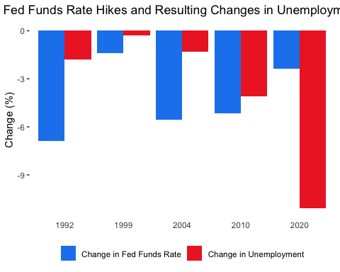

hike_plot

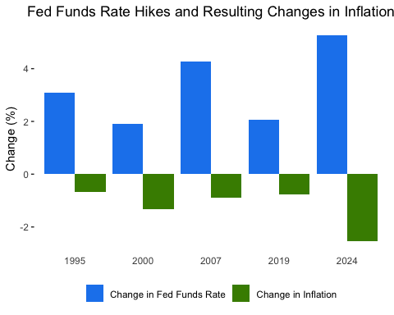

# Final Plot

This final plots shows that the Fed typically succeeds in its dual mandate. After each cut cycle, we typically see unemployment decrease. After each hike cycle, we typically see inflation decrease. This plot, however, also shows that contradictory nature of the dual mandate. After many cut cycles, we see some increase in inflation, and after many hike cycles, we see some increase in unemployment. Historical context is important here, as sometimes the Fed may intend to drive up some unemployment to “cool” the economy. Similarly, it may sometimes intend to increase inflation during periods of high disinflation. Regardless, this plot helps us determine that cuts typically drive higher employment and hikes typically drive lower inflation.

caption <- str_c(  
 'NOTE:',  
 '\n Each year corresponds to a period of rate cuts / hikes and a period of observation for unemployment and inflation.',  
 '\n The details of each cycle are provided below.'  
)  
   
for (row in 1:nrow(cut_cycles)) {  
 cut_caption <- str_c(year(cut_cycles[row, 'end']), ' – ', cut_cycles[row, 'label'])  
 caption <- str_c(caption, '\n ', cut_caption)  
   
 hike_caption <- str_c(year(hike_cycles[row, 'end']), ' – ', hike_cycles[row, 'label'])  
 caption <- str_c(caption, '\n ', hike_caption)  
}  
  
caption <- str_c(caption, '\n Sources: Fed Funds Rates data are from FRED. Inflation and Unemployment data are from BLS.')  
  
final_plot <- rbind(cut_cycles, hike_cycles) %>%  
 pivot_longer(cols = c(ff_change, ue_change, infl_change)) %>%  
 filter(!is.na(value)) %>%  
 mutate(label = fct_reorder(label, end), end = as.character(year(end))) %>%  
 arrange(end) %>%  
 ggplot(aes(x = end, y = value, fill = name)) +  
 geom_col(position = position_dodge(), width = 0.75) +  
 labs(  
 x = 'End of Rate Cycle (Year)', y = 'Change (%)',   
 title = 'Fed Funds Rate Cuts / Hikes and Resulting Changes in Unemployment / Inflation',  
 caption = caption  
 ) +  
 scale_fill_manual(  
 values = c(  
 'ff_change' = 'azure2',  
 'ue_change' = 'wheat2',  
 'infl_change' = 'sienna1'  
 ),  
 labels = c(  
 'ff_change' = 'Change in Fed Funds Rate',  
 'ue_change' = 'Change in Unemployment',  
 'infl_change' = 'Change in Inflation'  
 ),   
 name = NULL,  
 ) +  
 scale_x_discrete(position = 'bottom') +  
 geom_text(  
 aes(label = round(value,1), y = ifelse(value > 0, value + 1, value - 1)),  
 position = position_dodge(0.8),  
 color = "black", size = 3.2  
 ) +  
 theme(  
 plot.title.position = 'plot',  
 plot.title = element_text(hjust = 0.5),  
 plot.caption = element_text(hjust = 0),  
 panel.background = element_blank(),  
 legend.position = 'bottom', legend.box = 'vertical',  
 axis.ticks.x = element_blank(),  
 axis.title.x = element_text(margin = margin(t = 15, b = 10))  
 )  
  
final_plot

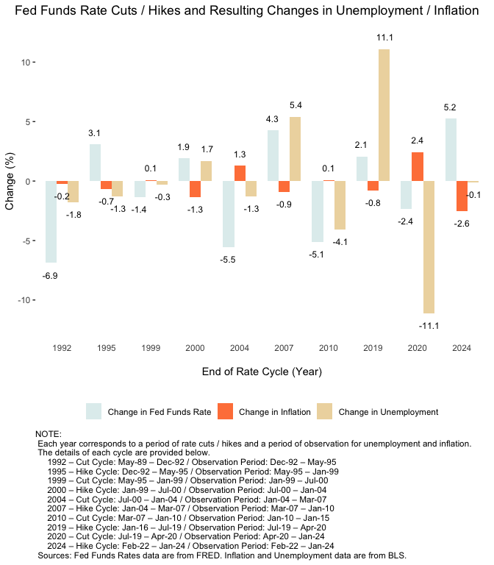

ggsave('story2_waheeb_finalPlot.png', plot = final_plot, width = 7, height = 8, dpi = 500)